Course Name | ITD 2313 – Script Programming
Instructor | Prof. Greg Morris
Student Name | Dean Ramsey
Due date | 11/9/2025
Grade | Put grade earned here
Grading Comments | Put instructor comments here

Week 10 - Scripting Projects Assignment

Project 1:
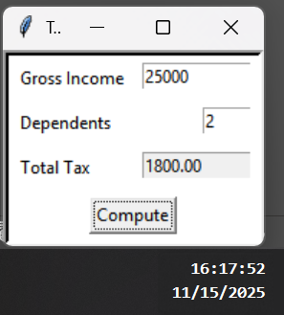
Project 3:
